Programming I
Working with Files in Python

File Input and Output

Have you ever wondered how your favorite computer game remembers the high scores,
even after the computer is turned off? How about your browser remembering your favorite web sites? In this lesson, you are going to learn how.

We have seen how programs have three main aspects: input, processing, and output. Up until now, the input has mostly come directly from the user, from the keyboard and mouse. The output has been sent directly to the screen (or the speakers, in the case of sound). But sometimes we need to use input that comes from other sources.

Quite often, programs need to use input that’s stored somewhere, rather than entered
when the program is running. Some programs need to get their input from a file on the
computer’s hard drive.

For example, if you made a game of Hangman, your program would need a word list from which to choose the secret word. That list of words would have to be stored somewhere, probably in a “word list” file that goes with the program. The program would need to open this file, read the word list, and pick a word to use.

The same thing is true for output. Sometimes the output of a program needs to be stored.
All the variables that a program uses are temporary—they’re lost when the program stops
running. If you want to save some of the information to use later, you have to store it somewhere more permanent, like on the hard drive. For example, if you want to keep a list of high scores for a game, you need to store them in a file so that, next time the program runs, it can read the file and display the scores.

In this lesson, you will see how to open files and how to read and write them (get information from them and store information to them).

What’s a file?

Before you learn about opening, reading, and writing files, you need to learn about what
a file is. Previously you learned that computers store information in binary format, which just uses 1s and 0s. Each 1 or 0 is called a bit, and a group of eight bits is called a byte. A file is a collection of bytes that has a name and is stored on a hard drive, CD, DVD, floppy drive, flash drive, or some other kind of storage.

Files can store many different kinds of information. A file can have text, pictures, music,
computer programs, a list of phone numbers, and so on. Everything that’s stored on your
computer’s hard drive is stored as files. Programs are made of one or more files. Your computer’s operating system (Windows, or Mac OS X, or Linux, for example) has many, many files that it needs to run.

Files have the following properties:
- a name
- a type, which indicates what kind of data is in the file (picture, music, text)
- a location (where the file is stored)
- a size (how many bytes are in the file)

Filenames

In most operating systems (including Windows), part of the filename is used to tell you
what type of data is in the file. Filenames usually have at least one “dot” (the period symbol) in the name. The part after the dot tells you what kind of file it is. That part is called the extension.

Here are a few examples:
- In my_letter.txt the extension is .txt, which stands for “text,” so this file probably has text in it.
- In my_song.mp3, the extension is .mp3, which is a kind of sound file.
- In my_program.exe, the extension is .exe, which stands for “executable.” So .exe files are usually programs that you can run.
- In my_cool_game.py, the extension is .py, which usually means a Python program.

One important thing to know is that you can name a file anything you want, and use any
extension. You can make a text file (in Notepad, for instance) and call it my_notes.mp3. That does not make it a sound file. It still has just text in it, so it’s really a text file. You have just given it a file extension that makes it look like it’s a sound file, which will probably confuse people and computers. When naming a file, it’s a very good idea to use a file extension that matches what kind of file it is.

File locations

Up until now, we have been working with files that are stored in the same location as the
program itself. We haven’t worried about how to find the file, because it’s in the same place as the program. Every file needs to be stored somewhere, so in addition to a name, every file has a location. Hard drives and other storage media are organized into folders or directories. Folders and directories are two names for the same thing. They’re a way of grouping files together. The way the folders or directories are arranged and connected is called a folder structure or directory structure.

In Windows, each storage media has a letter, like C for the hard drive, or maybe E for a flash drive. In Mac OS X and Linux, each storage media has a name (for example, hda or
FLASH DRIVE). Each storage unit can be divided up into a number of folders, such as Music, Pictures, and Programs. If you look at it in a file viewer like Windows Explorer, it will look like this:

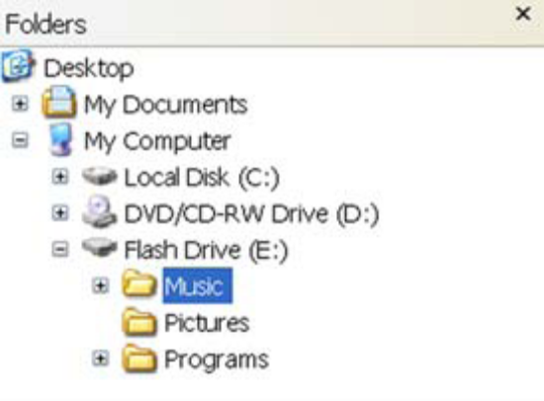
Folders can also have other folders within them, and those folders can have other folders within them, and so on. Here’s an example of three levels of folders:

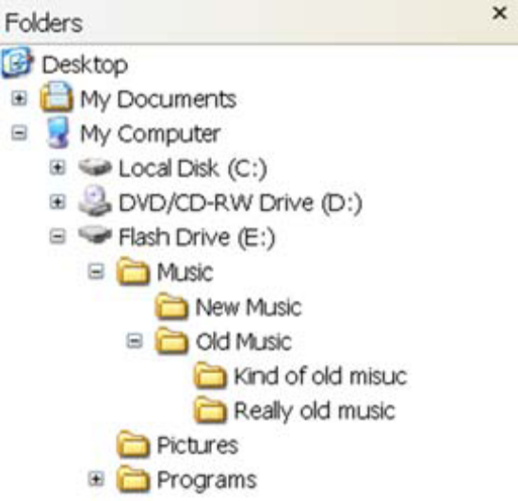

The first level is Music. The next level has New Music and Old Music, and the next level has Kind of old music and Really old music.

When you’re trying to find a file or folder in Windows Explorer (or some other file browser), the folders are like branches of a tree. The “root” is the drive itself, like C: or E:. Each main folder is like a main branch of the tree. The folders within each main folder are like smaller branches, and so on.

But when you need to access files from within a program, the tree idea doesn’t quite work. Your program can’t click on folders and browse around the tree to find individual files. It needs a more direct way to find the file. Fortunately, there’s another way to represent the tree structure. If you look in the address bar of Windows Explorer when you click on different folders and subfolders, you’ll see something that looks like this:
e:\Music\Old Music\Really old music\my_song.mp3

That’s called the path. The path is a description of where the file is in the folder structure.
This particular path reads like this:
- Start at the e: drive.
- Go into the folder called Music.
- In the Music folder, go into a subfolder called Old Music.
- In the Old Music subfolder, go into a subfolder called Really old music.
- In the Really old music subfolder, there’s a file called my_song.mp3.

You can get to any file on your computer using a path like this. That’s the way programs find and open files. Here’s an example:

image_file = "c:\program files\HelloWorld\examples\beachball.png"

You can always get to a file using its full pathname. That’s the name including all the folder names right down the tree to the root (the drive, like c:). The name in this example is a full pathname.

Slash or backslash?

It’s important that the slashes (\ and /) go the right way. Windows will accept either a forward slash (/) or a backslash (\) in pathnames, but if you use something like c:\test_results.txt in a Python program, the \t part will cause a problem. Remember, there are special characters for print formatting, like \t for tab? That’s why you should avoid the \ character in file paths. Python (and Windows) will treat \t as a tab character instead of part of your filename as you intended. Use / instead. The other option is to use double backslashes, like this:

image_file "c:\\program files\\HelloWorld\\images\\beachball.png"

Remember that, if you want to print a \ character, you have to put another one in front of it. It works the same way in filenames.

Sometimes you don’t need the whole file path. The next section talks about finding a file if you’re already partway down the path.

Finding where you are

Most operating systems (including Windows) have the idea of a “working directory,”
sometimes called the “current working directory.” This is the directory in the folder tree
you’re currently working in. Imagine that you started at the root (c:), and you moved down the Program Files branch to the HelloWorld branch. Your current location or current directory would be c:/Program Files/HelloWorld.

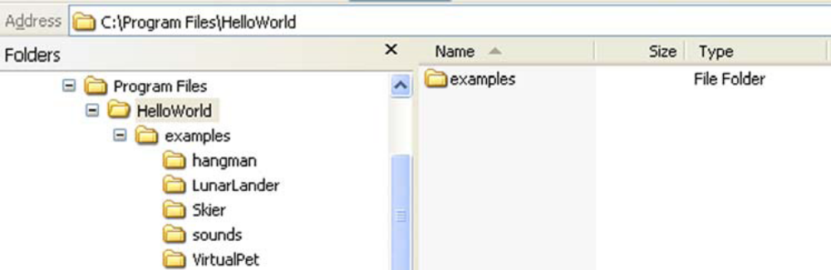

Now, to get to the file called beachball.png, you have to go down the examples branch.
So your path to get there would be /examples/beachball.png. Because you were already
partway down the right path, you only needed the rest of the path to get where you
wanted to go.

Opening a file

Before you open a file, you need to know what you’ll be doing with the file:
- If you’ll be using the file as input (looking at what’s in the file without changing it), you’ll open the file for reading.
- If you’ll be creating a brand new file or replacing an existing file with something brand new, you’ll open the file for writing.
- If you’ll be adding to an existing file, you’ll open the file for appending.

When you open a file, you make a file object in Python. You make the file object by using the open() function with the name of the file, like this:

my_file = open('my_filename.txt','r')

The filename is a string, so it needs quotes around it. The 'r' part means we’re opening the
file for reading. We’ll learn more about that in the next section. It’s important to understand the difference between the file object and the filename. The file object is what we’ll use inside the program to access the file. The filename is what Windows (and Linux and Mac OS X) calls the file on the disk.

We do the same thing with people. We have different names that we use in different
places. If your teacher’s name is Fred Weasley, you probably call him Mr. Weasley. His
friends probably call him Fred, and his computer username might be fweasley. With files,
there’s a name that’s used by the operating system to store the file on disk (the filename),
and there’s a name your program uses when working with the file (the file object). The two names—the name of the object and the name of the file—don’t have to be the same. You can call the object whatever you want. For example, if we have a text file with
some notes in it that’s called notes.txt, we could do this:

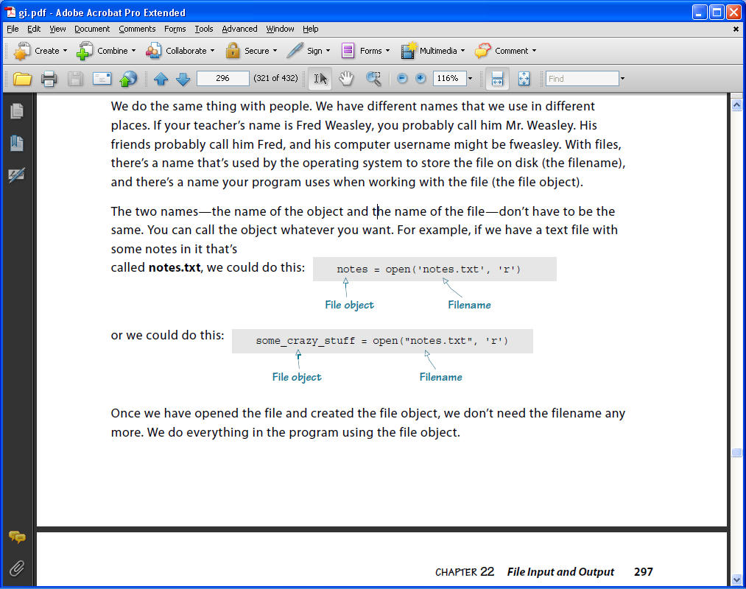

or we could do this:

Once we have opened the file and created the file object, we don’t need the filename any
more. We do everything in the program using the file object.

Reading a file

As I mentioned in the last section, we open a file and create a file object using the open()
function. This is one of Python’s built-in functions. To open the file for reading, you use 'r' as the second argument, like this:

my_file = open('notes.txt', 'r')

If you try to open a file for reading that does not exist, you’ll get an error. Python has a couple more built-in functions for getting information from the file into our program once the file is open. To read lines of text from a file, you can use the readlines() method, like this:

lines = my_file.readlines()

This will read the whole file and make a list, with one line of text in each item of the list.
Let’s say the notes.txt file contained a short list of things you need to do today:

Wash the car
Make my bed
Collect allowance

We could have used a program like Notepad to create this file. In fact, why don’t you make a file like this using Notepad right now? Call it notes.txt and save it in the same place you save your Python programs. Then close Notepad.

If we open this file with a short Python program and read it, the code might look like
the listing below.

my_file = open('notes.txt', 'r')
lines = my_file.readlines()
print (lines)

The output would be like this (depending on what you put in the file):

>>>======================= RESTART =========================
>>>
['Wash the car\n', 'Make my bed\n', 'Collect allowance']
>>>

The lines of text were read from the file and they were put into a list, which we called lines. Each item in the list is a string containing one line from the file. Notice the \n part at the end of the first two lines. These are the newline characters that separate the lines in the file. That’s where we pressed Enter when we were creating the file. If you pressed Enter after typing in the last line, there will be a third \n after the third item.

There’s one more thing we need to add to the program listing above. When we’re
done with the file, we should close it:

my_file.close()

Once the file is in our program as a list of strings, we can do whatever we want with it. This list is just like any other Python list, so we can loop through it, sort it, append items, delete items, and so on. The strings are like any other strings, so we can print them, convert them to int or float (if they contain numbers), use them as labels in a GUI, or do anything else that you’d do with a string.

Reading one line at a time

The readlines() method reads all the lines of a file, right up until the end of the file. If you want to read just one line at a time, you can use the readline() method, like this:

first_line = my_file.readline()

This will read just the first line of the file. If you use readline() again in the same program, Python remembers where it was. So the second time you use it, you’ll get the second line of the file. The listing below shows an example of this.

my_file = open('notes.txt', 'r')
first_line = my_file.readline()
second_line = my_file.readline()
print ("first line = ", first_line)
print ("second line = ", second_line)
my_file.close()

The output of that program would look like this:

>>>================== RESTART ====================
>>>
first line = Wash the car
second line = Make my bed
>>>
The readline() method only reads one line at a time, so it doesn’t put the results into a list.
Each time you use readline(), you get a single string.

Going back to the start

If you have used readline() a few times and you want to start back at the beginning of the
file, you can use the seek() method, like this:

first_line = my_file.readline()
second_line = my_file.readline()
my_file.seek(0)
first_line_again = my_file.readline()

The seek() method makes Python go to whatever place in the file you tell it. The number in brackets is the number of bytes from the start of the file. So setting it to 0 takes it right back to the start of the file.

Text files and binary files

All the examples of opening files and reading lines of text so far are assuming one thing: the file actually has text in it! Remember that text is just one of the kinds of things we can store in a file. Programmers lump together all other kinds of files and call them binary files.

There are two main types of files you can open:
- Text files—These have text in them, with letters, numbers, punctuation, and some special characters, like newlines.
- Binary files—These don’t have text in them. They might have music, pictures, or some kind of data, but because they don’t have text, they don’t have lines either, because there are no newlines.

That means you can’t use readline() or readlines() on a binary file. If you try to read a
“line” from a .wav file, for example, you don’t know what you’ll get. Most likely, you’ll get a whole bunch of gobbledygook that looks like this:

>>> f = open('splat.wav', 'r')
>>> print f.readline()
RIFFö? WAVEfmt ? ? ? "V "V datap? ÇÇÇÇÇÇÇÇüÇÇÇÇÇÇÇÇÇÇÇÇÇÇÇ?ÇÇ?????Ç????Ç
ÇÇÇ??ÇÇÇÇÇÇÇÇÇÇÇÇÇÇÇÇ?Ç?ÇÇÇÇüÇÇÇÇÇÇÇÇÇÇÇÇÇÇÇÇ?ÇÇÇÇÇüüÇÇÇ?ÇÇ?ÇÇÇÇ??ÇÇüéééÇzvvy{|Ç
âçïê}trv|äëïîèå~ut|?yrqrtxÇîÖ?æäàütvçÆÄ|mlfWR]jnmpxüêÅ
ºƒâràó«¼Ö}`ORj?{hZZgwàëy{äæá?¿ÿézåÿèmWLISjÇàzrvÇüytv~üÇ}yrifjt}äêèêëÄöÉémSCFZ
lrtyéïö¥ñ¬½?ñ¢ÆÄìÅôòÆÄÅæ|åÜ?¬ÿüpd\UME@;99:>EJMW]YTZfuçòƒ?????????????¢ôë~{|{y
xzzuiZNGHLSbs?~wrnf\TPQU]`jvàæÉ?osÇïôæä}üàë??

There’s something that looks like text at the start of the .wav file, but then it gets crazy.
That’s because a .wav file doesn’t have text in it, it has sound. The readline() and
readlines() methods are only for reading text files.

Writing to a file

If you want to store some information from your program more permanently, you could
look at it on the screen and write it down on a piece of paper. But that kind of defeats the
purpose of using a computer.

A better idea is to save the information on the hard drive, so that, even when the program
isn’t running—in fact, even when the computer is turned off—your data is still there and
you can get it later. You have done this many, many times already. Every time you save a
report for school, a picture, a song, or a Python program, you’re storing it to the hard drive.

As I mentioned earlier, there are two ways you can put things in a file:
- writing—This means starting a new file or overwriting an existing one.
- appending—This means adding to an existing file and keeping what’s already there.

To write or append to a file, you first have to open the file. You use the open() function, just like we did before, except that the second parameter will be different:
- For reading, you use 'r' as the file mode: my_file = open('new_notes.txt', 'r')
- For writing, you use 'w' as the file mode: my_file = open('new_notes.txt', 'w')
- For appending, you use 'a' as the file mode: my_file = open('notes.txt', 'a')

If you use 'a' for append mode, the filename has to be one that already exists on the hard
drive, or you’ll get an error. That’s because append is for adding to an existing file.

If you use 'w' for write mode, there are two possibilities:
- If the file already exists, whatever is in the file will be lost and replaced with whatever you write there.
- If the file doesn’t exist, a new file with that name will be created, and whatever you write will go into the new file.

Appending to a file

First we’ll take the notes.txt file that we created earlier and append something to it. Let’s
add another line that says “Spend allowance.” If you were looking closely when we did the readlines() example, you might have noticed that there’s no \n, no newline, at the end of the last line. So we need to add one, and then add our new string. To write strings to a file, we use the write() method, like in the listing below

todo_list = open('notes.txt', 'a')
todo_list.write('\nSpend allowance')
todo_list.close()

When we were reading files, you should close the file when you’re done. But it’s
even more important to use close() when you’re done writing. That’s because the changes don’t actually get saved to the file until you close() it.

After you run the program in the listing above, open notes.txt using Notepad (or any other text editor) and see what’s in it. Remember to close Notepad when you’re done.

Writing to a file

Now let’s try an example of writing to a file using the write mode. We’ll open a file that isn’t on the hard drive. Type in the program in the listing below and run it.

new_file = open("my_new_notes.txt", 'w')
new_file.write("Eat supper\n")
new_file.write("Play soccer\n")
new_file.write("Go to bed")
new_file.close()

How do you know it worked? Check in the folder where you saved the program from the listing above. You should see a file there called my_new_notes.txt. You can open this file in Notepad to see what’s in it. You should see this:

Eat supper
Play soccer
Go to bed

You created a text file with this program and stored some text in it. This text is on the hard drive, and it’ll stay there forever—or at least as long as the hard drive keeps working— unless you delete it. So we have a way to permanently store data from our programs. Now your programs can leave a permanent mark on the world (or at least on your hard drive).

Anything you need to keep when the program stops and the computer is shut off, you can
put in a file. Let’s see what happens if we use write mode on a file that’s already on the hard drive.

todo_list = open('notes.txt', 'a')
todo_list.write('\nSpend allowance')
todo_list.close()

Remember our file called notes.txt? If you ran the program in listing above, it looks like this:

Wash the car
Make my bed
Collect allowance
Spend allowance

Let’s open this file in write mode and write to it, to see what happens. The listing below has the code.

the_file = open('notes.txt', 'w')
the_file.write("Wake up\n")
the_file.write("Watch cartoons")
the_file.close()

Run this code, and then open notes.txt in Notepad to see what it contains. You should
see this:

Wake up
Watch cartoons

The stuff that was in notes.txt before is gone. It has been replaced by the new stuff from the program in the listing above.

Writing to a file using print

In the last section, we wrote to a file using write(). You can also use print to write to a file. You still have to open the file in write or append mode, but then you can write to the file using print, like this:

my_file = open("new_file.txt", 'w')
print("Hello there, neighbor!", file = my_file)
my_file.close()

The file parameter sends the text to the file handle my_file instead of the screen. This is called redirecting output. Sometimes it’s more convenient to use print than write(), because print does things like automatically converting numbers to strings, and so on. You can decide whether to use print or write() to put text into a file.

Saving your stuff in files: pickle

In the first part of this lesson, you learned about reading and writing text files. Text files are one way you can store things to the hard drive. But what if you want to store something like a list or an object? Sometimes the items in the list might be strings, but not always. And what about storing things like objects? You might be able to convert all the object’s properties to strings and write them to a text file, but then you’d have to do the opposite to go from the file back to an object. It could get complicated.

Luckily, Python has a way to make storing things like lists and objects easier. It’s a Python module called pickle. That’s kind of a strange name, but if you think about it: pickling is a way of preserving food so you can use it later. In Python, you “pickle” your data so you can save it on disk and use it later.

Pickling

Let’s say we have a list with different kinds of things in it,
like this:

my_list = ['Fred', 73, 'Hello there', 81.9876e-13]

To use pickle, first you have to import the pickle module:

import pickle

Then to “pickle” something, like a list, you use the dump() function. That’s easy to
remember if you think of dumping your pickles into the jar. The dump() function needs
a file object, and we know how to make one of those:

pickle_file = open('my_pickled_list.pkl', 'w')

We open it for writing with 'w' because we’re going to be storing something in this file. You can pick whatever name and extension you want. I picked .pkl as the extension, short for “pickle.”

Then we dump() our list into the pickle file:

pickle.dump(my_list, pickle_file)

The whole process looks like the listing below.

import pickle
my_list = ['Fred', 73, 'Hello there', 81.9876e-13]
pickle_file = open('my_pickled_list.pkl', 'wb')
pickle.dump(my_list, pickle_file)
pickle_file.close()

You can use this same method to store any kind of data structure to a file. But what about
getting it back?

Unpickling

In real life, once you pickle something, it stays pickled. You can’t undo it. But in Python,
when you “preserve” some data by pickling it, you can also reverse the process and get your data back the way it was.

The function to “unpickle” something is load(). You give it a file object for the file that
contains the pickled data, and it gives you back the data in its original form. Let’s try it. If
you ran the program in the listing above, you should have a file called my_pickled_list.pkl in the same place where you store your programs. Now try the program in the listing below and see if you get the same list back.

import pickle
pickle_file = open('my_pickled_list.pkl', 'rb')
recovered_list = pickle.load(pickle_file)
pickle_file.close()
print (recovered_list)

You should get output that looks like this:

['Fred', 73, 'Hello there', 8.1987599999999997e-012]

It looks like the unpickling worked! We got back the same items we pickled. The E-notation looks a little different, but it’s the same number, at least to 16 decimal places. The difference is from roundoff error.

